Hill Lane Surgery
Newsletter
November 2019

Hello and welcome to our newsletter.

Our flu clinic is up and running, please booked your flu jabs if you haven’t already done so.
‘Those eligible for a free flu shot under the National Immunisation Program include people 65 years and over, pregnant women, those who suffer chronic conditions as well as, for the first time, all Aboriginal and Torres Strait Islander People from 6 months of age.(6 Mar 2019)’
The cold weather is most definitely kicking in, so please protect yourself.

Have you seen our new NHS app?
You can order you prescriptions and book appointment via this app… please check it out.

Kind Regards
Laura
Practice Administrator
Hill Lane Surgery

--------------------------------------------------------

'Try the new NHS App’

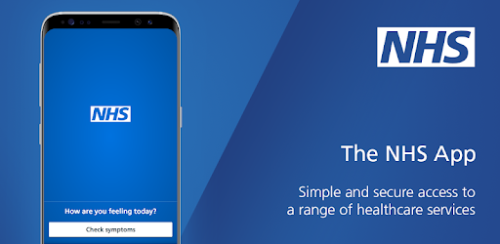

You can now use the new NHS App, a simple and secure way to access a range of NHS services on your smartphone or tablet.

You can use the NHS App to check your symptoms and get instant advice, book appointments, order repeat prescriptions, view your GP medical record and more.

If you already use our Hill Lane website, you can continue to use it. You can use the NHS App as well.

For more information go to www.nhs.uk/nhsapp

(You might also need to review existing website content to make sure it covers the different options patients have to connect with online services.)

--------------------------------------------------------

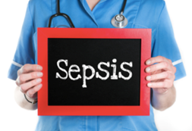

SEPSIS - a rare but serious complication of an infection.

Sepsis symptoms in children under five

Go straight to A&E or call 999 if your child has any of these symptoms:

• looks mottled, bluish or pale
• is very lethargic or difficult to wake
• feels abnormally cold to touch
• is breathing very fast
• has a rash that does not fade when you press it
• has a fit or convulsion

Get medical advice urgently from NHS 111
If your child has any of the symptoms listed below, is getting worse or is sicker than you'd expect (even if their temperature falls), trust your instincts and seek medical advice urgently from NHS 111.

Temperature
• temperature over 38C in babies under three months
• temperature over 39C in babies aged three to six months
• any high temperature in a child who cannot be encouraged to show interest in anything
• low temperature (below 36C – check three times in a 10-minute period)
Breathing
• finding it much harder to breathe than normal – looks like hard work
• making "grunting" noises with every breath
• can't say more than a few words at once (for older children who normally talk)
• breathing that obviously "pauses"
•
Toilet/nappies
• not had a wee or wet nappy for 12 hours

Eating and drinking
• new baby under one month old with no interest in feeding
• not drinking for more than eight hours (when awake)
• bile-stained (green), bloody or black vomit/sick
•
Activity and body
• soft spot on a baby's head is bulging
• eyes look "sunken"
• child cannot be encouraged to show interest in anything
• baby is floppy
• weak, "whining" or continuous crying in a younger child
• older child who's confused
• not responding or very irritable
• stiff neck, especially when trying to look up and down
•
If your child has any of these symptoms, is getting worse or is sicker than you'd expect (even if their temperature falls), trust your instincts and seek medical advice urgently from NHS 111.
Sepsis symptoms in older children and adults
Early symptoms of sepsis may include:
• a high temperature (fever) or low body temperature
• chills and shivering
• a fast heartbeat
• fast breathing
In some cases, symptoms of more severe sepsis or septic shock (when your blood pressure drops to a dangerously low level) develop soon after.
These can include:
• feeling dizzy or faint
• a change in mental state – such as confusion or disorientation
• diarrhoea
• nausea and vomiting
• slurred speech
• severe muscle pain
• severe breathlessness
• less urine production than normal – for example, not urinating for a day
• cold, clammy and pale or mottled skin
• loss of consciousness
•
When to get medical help
Seek medical advice urgently from NHS 111 if you've recently had an infection or injury and you have possible early signs of sepsis.If sepsis is suspected, you'll usually be referred to hospital for further diagnosis and treatment. Severe sepsis and septic shock are medical emergencies. If you think you or someone in your care has one of these conditions, go straight to A&E or call 999.

----------------------------------

Podiatry Drop In Service

The Podiatry Drop in Service, for anyone who requires information or advice.

‘Do you have problems with your feet?’, then you may find it useful to talk to a podiatrist at one of the local drop in sessions.

Drop in session run from 9am to 12pm and 1.30pm to 4pm at the following locations - please be aware that no treatment will be undertaken unless considered an emergency:

Contact number for both (single point of access): 0300 300 2012 or email: snhs.solentnhspodietry@nhs.net

Adelaide Health Centre, Western Community Hospital, William Macleod Way, Southampton SO16 4XE

Dates for 2019

Monday 4th and 18th November 2019

Monday 2nd and 16th December 2019

Monday 30th December 2020 (AM only)

Monday 13th and 27th January 2020

Monday 10th and 24th February 2020

Monday 9th and 23rd March 2020

Bitterne Health Centre, Commercial Street, Southampton, SO18 6BT

Monday 11th and 25th November 2019

Monday 9th December 2019

Monday 23rd December 2019 (AM only)

Monday 6th and 20th January 2020

Monday 3rd and 17th February 2020

Monday 2nd, 16th and 30th March 2020

--------------------------------------------------------

Interested in having a Yellow fever vaccination?

There is a questionaire on our website. These questions will help your health professional to decide if yellow fever vaccination is right for you.

